**“ADVANCE MAP MAPPING AND PATH FINDING SYSTEM USING MATLAB”**

A PROJECT REPORT

***Submitted by***

**MAHAVIR A RUPERA(130370111069)**

**MITUL S SENJALIYA(14037311015)**

**MAULIK J SHAH(140373111016)**

**KETAN M CHAUHAN (140373111020)**

*In partial fulfilment for the award of the degree*

*Of*

BACHELOR OF ENGINEERING

*In*

**(ELECTRONICS & COMMUNICATION ENGG.)**



**Parul Institute of Engineering & Technology,**

**Limda-391760.**

**Gujarat Technological University, Ahmedabad**

**December, 2016**

**PARUL INSTITUTE OF ENGINEERING AND TECHNOLOGY**

**ELECTRONICS &COMMUNICATION ENGINEERING.**

**2016**

# 

# CERTIFICATE

**Date:**

This is to certify that the project entitled **“ADVANCE MAP MAPPING AND PATH FINDING SYSTEM USING MATLAB”** has been carried out by **MAHAVIR A RUPERA(130370111069)** under my guidance in partial fulfilment of the degree of Bachelor of Engineering in Electronics & Communication (7th Semester) of Gujarat Technological University, Ahmedabad during the academic year 2016-2017.

**Guides:**

|  |  |
| --- | --- |
| **Internal Guide:**  Guide Name  Designation | **External Guide:**  Guide Name  Designation |
|  | **Head of the Department**  Prof. Anuradha Gharge |

**PARUL INSTITUTE OF ENGINEERING AND TECHNOLOGY**

**ELECTRONICS &COMMUNICATION ENGINEERING.**

**2016**

# CERTIFICATE

**Date:**

This is to certify that the project entitled **“ADVANCE MAP MAPPING AND PATH FINDING SYSTEM USING MATLAB”** has been carried out by **MITUL S SENJALIYA(140373111015)** under my guidance in partial fulfilment of the degree of Bachelor of Engineering in Electronics & Communication (7th Semester) of Gujarat Technological University, Ahmedabad during the academic year 2016-2017.

**Guides:**

|  |  |
| --- | --- |
| **Internal Guide:**  Guide Name  Designation | **External Guide:**  Guide Name  Designation |
|  | **Head of the Department**  Prof. Anuradha Gharge |

**PARUL INSTITUTE OF ENGINEERING AND TECHNOLOGY**

**ELECTRONICS &COMMUNICATION ENGINEERING.**

**2016**

# CERTIFICATE

**Date:**

This is to certify that the project entitled **“ADVANCE MAP MAPPING AND PATH FINDING SYSTEM USING MATLAB”** has been carried out by **MAULIK J SHAH (140373111016)** under my guidance in partial fulfilment of the degree of Bachelor of Engineering in Electronics & Communication (7th Semester) of Gujarat Technological University, Ahmedabad during the academic year 2016-2017.

**Guides:**

|  |  |
| --- | --- |
| **Internal Guide:**  Guide Name  Designation | **External Guide:**  Guide Name  Designation |
|  | **Head of the Department**  Prof. Anuradha Gharge |

**PARUL INSTITUTE OF ENGINEERING AND TECHNOLOGY**

**ELECTRONICS &COMMUNICATION ENGINEERING.**

**2016**

# CERTIFICATE

**Date:**

This is to certify that the project entitled **“ADVANCE MAP MAPPING AND PATH FINDING SYSTEM USING MATLAB”** has been carried out by **KETAN M CHAUHAN(140373111020)** under my guidance in partial fulfilment of the degree of Bachelor of Engineering in Electronics & Communication (7th Semester) of Gujarat Technological University, Ahmedabad during the academic year 2016-2017.

**Guides:**

|  |  |
| --- | --- |
| **Internal Guide:**  Guide Name  Designation | **External Guide:**  Guide Name  Designation |
|  | **Head of the Department**  Prof. Anuradha Gharge |

# Completion Certificate from GTU

# Plagiarism Check Report from Different Website .

# Acknowledgement

I, hereby, …………………………

**MAHAVIR A RUPERA (130370111069)**

**MITUL S SENJALIYA(140373111015)**

**MAULIK J SHAH (140373111016)**

**KETAN M CHAUHAN (140373111020)**

**ABSTRACT**

Our project is “**ADVANCE MAP MAPPING AND PATH FINDING SYSTEM USING MATLAB”.** This project can used for military purpose. It is used to detect the object using ultrasonic distance sensor. Ultrasonic distance sensor sense from short distance to long distance accurately. In this project used **AVR 328 MICROCONTROLLER**. Microcontroller interfaced with **ultrasonic distance** **sensor** and **CC2500 RF module** for detecting purpose. Our project detect the object of consider area or room using ultrasonic sensor. Our project save the **INDIAN ARMY** for terrorist attack. **ADVANCE MAP MAPPING AND PATH FINDING SYSTEM USING MATLAB** project making the map in MATLAB software. Using servo motor all area detect the different- different angle.

**INDEX**

1.Introduction....................................................................................9

2.Modelling and Analysis using Software**:......................................................................**9

3. Engineering Economics of Design: ...............................................................15

4. Design for Use, Reuse and Sustainability :.,...........................................15

5. Prototyping: ..................................................................................................16

6. Test the prototype :.........................................................................................29

7. Measuring Instruments/ techniques-open source tool ...................................33

8. Comparison of existing materials, methods,tools..........................................34

9. Conclusion/Future scope ...............................................................................36

# Index

CERTIFICATE II

Completion Certificate III

Plagiarism IV

Acknowledgement V

Abstract VI

Index 1

List of Figure 3

List of Table 4

Chapter 1 Introduction 5

1.1 Problem Summary or Introduction 5

1.2 Aims and Objectives of the work 6

1.3 Usefulness of the project to the industry/user /society 6

Chapter 2 Literature review and work plan 7

2.1 Literature review 7

Chapter 3 Hardware and Software Description 8

3.1 Hardware 8

Chapter 4 Results and Outcomes 9

4.1 Results 9

Chapter 5 Conclusion and Future Work 10

5.1 Conclusion 10

References 11

Annexure 1 Chart 1 12

Annexure 2 chart 2 13

Annexure 3 chart 3 14

Appendix 15

# List of Figure

Fig 1.1 timeline 5

# List of Table

Table 1.1 Matrix m defined in H.264 standard 5

# Introduction

1. Problem Summary or Introduction **Introduction**

As define abstract our project is “**ADVANCE MAP MAPPING AND PATH FINDING SYSTEM IN MATLAB”.**

### Subtitle

Content

Put figure like this [1]

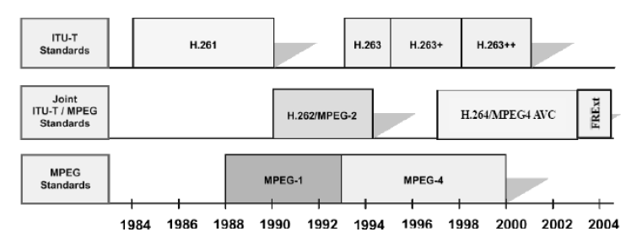

Fig 1.1 timeline

Put table like this [1]

|  |  |  |  |
| --- | --- | --- | --- |
| QP | **m(r, 0): Mf positions**  **(0,0), (0,2),(2,0), (2,2)** | **m(r, 1): Mf positions**  **(1,1), (1,3),(3,1), (3,3)** | **m(r,2):**  **Remaining Mf  positions** |
| 0 | 13107 | 5243 | 8066 |
| 1 | 11916 | 4660 | 7490 |
| 2 | 10082 | 4194 | 6554 |
| 3 | 9362 | 3647 | 5825 |
| 4 | 8192 | 3355 | 5243 |
| 5 | 7282 | 2893 | 4559 |

Table 1.1 Matrix m defined in H.264 standard

## Aims and Objectives of the work

## Usefulness of the project to the industry/user /society

Same way create ALL Chapters

# Literature review and work plan

## Literature review

# Hardware and Software Description

## Hardware

Component list

**AVR AT mega 328 Micro controller**

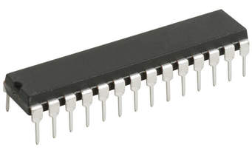

The Atmel [8-bit](https://en.wikipedia.org/wiki/8-bit) [AVR](https://en.wikipedia.org/wiki/Atmel_AVR) [RISC](https://en.wikipedia.org/wiki/Reduced_instruction_set_computing)-based microcontroller combines 32 KB [ISP](https://en.wikipedia.org/wiki/In-system_programming) [flash](https://en.wikipedia.org/wiki/Flash_memory) memory with read-while-write capabilities, 1 KB [EEPROM](https://en.wikipedia.org/wiki/EEPROM), 2 KB[SRAM](https://en.wikipedia.org/wiki/Static_random-access_memory), 23 general purpose I/O lines, 32 general purpose working [registers](https://en.wikipedia.org/wiki/Processor_register), three flexible timer/[counters](https://en.wikipedia.org/wiki/Counter_(digital)) with compare modes, internal and external [interrupts](https://en.wikipedia.org/wiki/Interrupt), serial programmable [USART](https://en.wikipedia.org/wiki/USART), a byte-oriented 2-wire serial interface, [SPI](https://en.wikipedia.org/wiki/Serial_Peripheral_Interface_Bus) serial port, 6-channel 10-bit [A/D converter](https://en.wikipedia.org/wiki/A/D_converter) (8-channe ls in [TQFP](https://en.wikipedia.org/wiki/Quad_Flat_Package) and [QFN](https://en.wikipedia.org/wiki/Quad_Flat_No-leads_package)/[MLF](https://en.wikipedia.org/wiki/Quad-flat_no-leads_package#Variants) packages), programmable [watchdog timer](https://en.wikipedia.org/wiki/Watchdog_timer) with internal [oscillator](https://en.wikipedia.org/wiki/Electronic_oscillator), and five software selectable power saving modes. The device operates between 1.8-5.5 volts. The device achieves throughput approaching 1 [MIPS](https://en.wikipedia.org/wiki/Million_instructions_per_second#Million_instructions_per_second) per MHz.

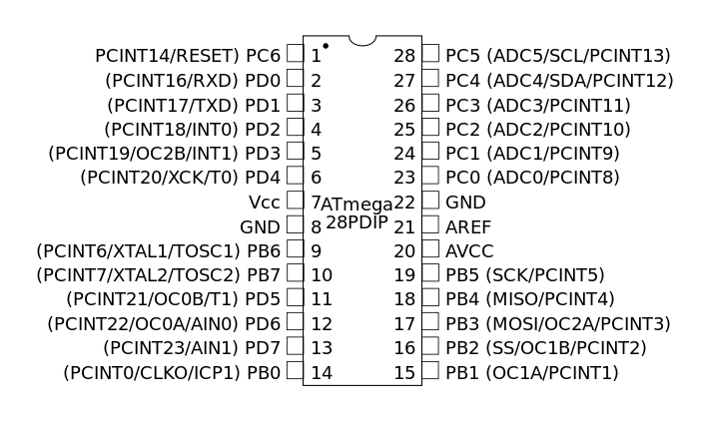

**28 Pin IC Socket**

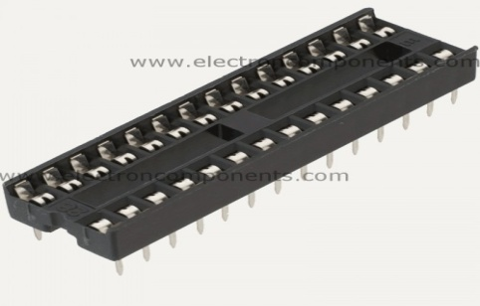

* Voltage rating: 250V AC/DC
* Current rating: 1A AC/DC
* Max. Voltage Isolation: 1000V AC for 1 minute
* Isolation Resistance: 1000 MΩ
* Temperature Range: -40°C to +105°C
* Contact Resistance: 20 mΩ
* Contact Material: Phosphor Bronze, Tin plated.

**RS-232 Standard**

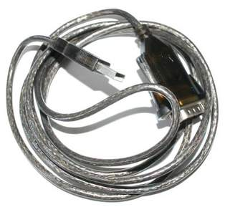

Information being transferred between data processing equipment and peripherals is in the form of digital data which is transmitted in either a serial or parallel mode. Parallel communications are used mainly for connections between test instruments or computers and printers, while serial is often used between computers and other peripherals. Serial transmission involves the sending of data one bit at a time, over a single communications line. In contrast, parallel communications require at least as many lines as there are bits in a word being transmitted (for an 8-bit word).

**L298 Motor driver module**

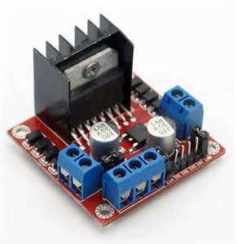

This motor driver module controls the speed and direction on 2 DC motors, up to 40V 3A. The module itself is powered and controlled from a gangster main board but the motors are powered from a separate power source. A battery can be safely used to power the input on the gadgeteer power module (a red module, like USB Client DP) and also power the motors, by wiring the battery to both.

7805 Voltage regulator IC

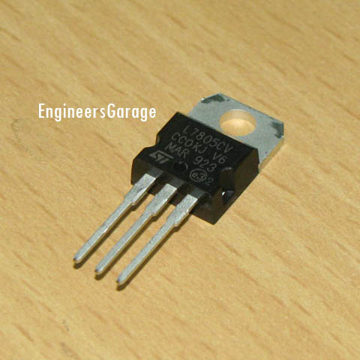

**7805** is a **voltage regulator** integrated circuit. It is a member of 78xx series of fixed linear voltage regulator ICs. The voltage source in a circuit may have fluctuations and would not give the fixed voltage output. The **voltage regulator IC** maintains the output voltage at a constant value. The xx in 78xx indicates the fixed output voltage it is designed to provide. 7805 provides +5V regulated power supply. Capacitors of suitable values can be connected at input and output pins depending upon the respective voltage levels.

**89s52 Micro controller**

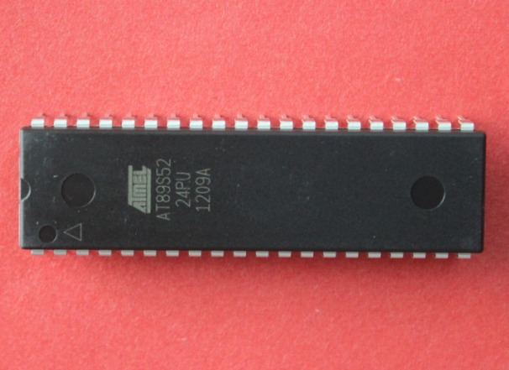

The AT89S52 is a low-power, high-performance CMOS 8-bit microcontroller with 8K bytes of in-system programmable Flash memory. The device is manufactured using Atmel’s high-density nonvolatile memory technology and is compatible with the industry-standard 80C51 instruction set and pinout. The on-chip Flash allows the program memory to be reprogrammed in-system or by a conventional nonvolatile memory programmer. By combining a versatile 8-bit CPU with in-system programmable Flash on a monolithic chip, the Atmel AT89S52 is a powerful microcontroller which provides a highly-flexible and cost-effective solution to many embedded control applications.

**1000 uf capacitor**

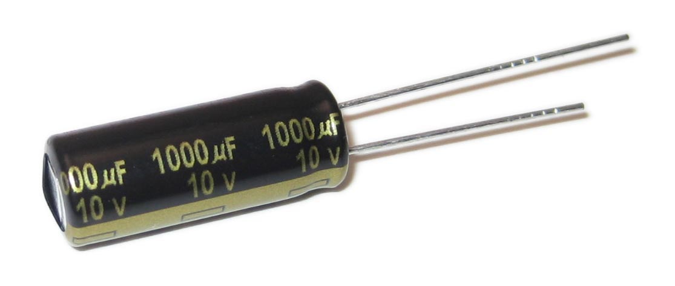

Electrolytic decoupling capacitors 1000uF/25V. These capacitors are great transient/surge suppressors and work well in high-voltage and audio applications. High quality radial electrolytic capacitors. If you need a bunch of these, you can get good bulk discounts on Dig key, part # : P5156-ND.

**1N4007 Diode**

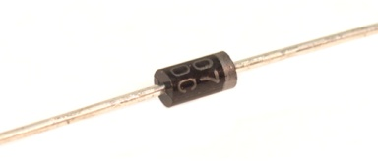

The 1N4001 series  is a family of popular 1.0 A ([ampere](https://en.wikipedia.org/wiki/Ampere)) general-purpose [silicon](https://en.wikipedia.org/wiki/Silicon) [rectifier](https://en.wikipedia.org/wiki/Rectifier) [diodes](https://en.wikipedia.org/wiki/Diode) commonly used in [AC adapters](https://en.wikipedia.org/wiki/AC_adapter#AC_adapter) for common household appliances. [Blocking voltage](https://en.wikipedia.org/wiki/Breakdown_voltage) varies from 50 to 1000 volts. This diode is made in an axial-lead [DO-41](https://en.wikipedia.org/wiki/DO-41)plastic package. The 1N5400 series is a similarly popular series for higher current applications, up to 3 A. These diodes are typically available in the larger DO-201AD axial package to dissipate heat better.

**L298 Motor driver module**



The L298N driver module, using ST' L298N chip, can directly drive two 3-30V DC motor, and provide a 5V output interface, power for 5V single-chip circuitry , support 3.3VMCU control. you can easily control the DC motor speed and direction, also control the 2-phase stepper motor. It is essential for making a smart car.

Driver: L298N Dual H Bridge DC Motor Driver IC

Driven part of the terminal supply area Vs: +5 V ~ +35 V; such as the need to take power within the board, the supply area Vs: +7 V ~ +35 V  
Driven part of the peak current Io: 2A  
The logical part of the terminal supply area Vss: +5 V ~ +7 V (can take power within the board +5 V)  
The logical part of the operating current range: 0 ~ 36mA  
Control signal input voltage range:  
Low:-0.3V ≤ Vin ≤ 1.5V  
High: 2.3V ≤ Vin ≤ Vss  
Enable signal input voltage range:  
Low: -0.3 ≤ Vin ≤ 1.5V (control signal is invalid)  
High: 2.3V ≤ Vin ≤ Vss (control signal active)  
Maximum power consumption: 20W (when the temperature T = 75 ℃)  
Storage temperature: -25 ℃ ~ +130 ℃  
Other Extensions: control of direction indicators, the logic part of the plate to take power interface.  
Driver Board Size: 55mm * 60mm * 30mm

**12 v Battery**

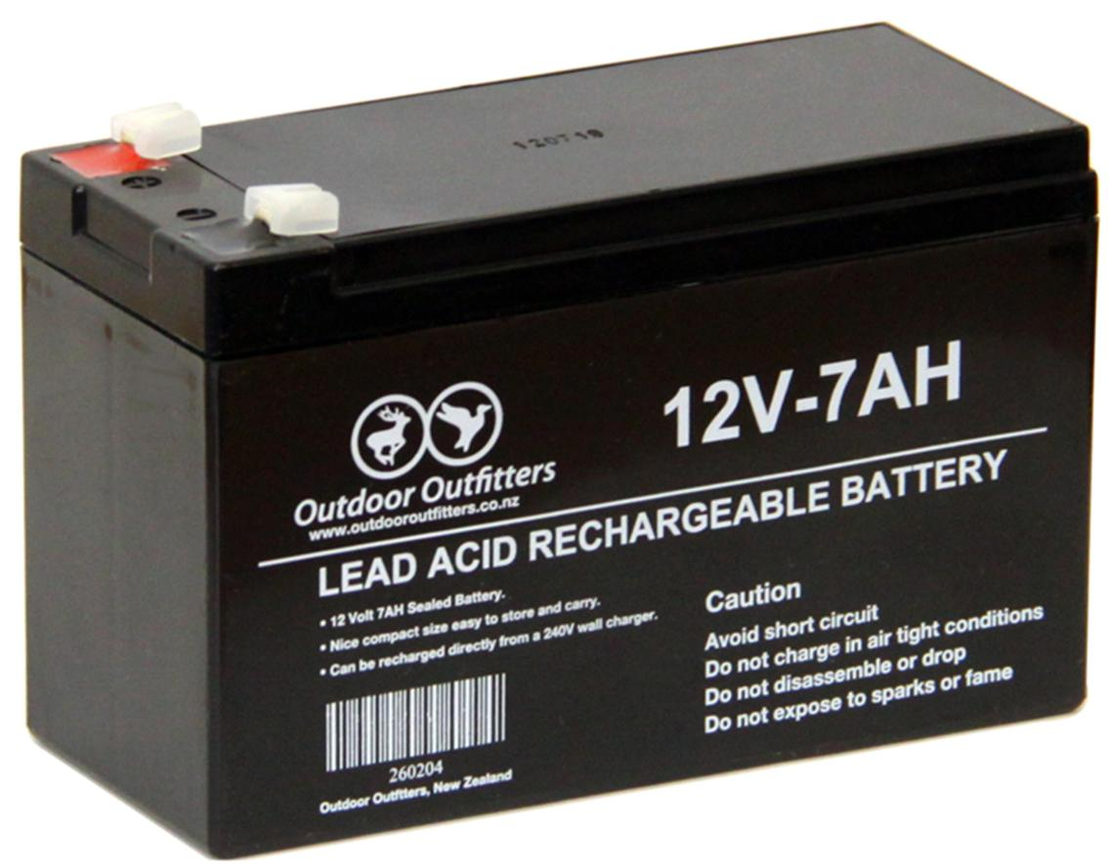

An automotive battery is a [rechargeable battery](https://en.wikipedia.org/wiki/Rechargeable_battery) that supplies electric energy to an automobile. Traditionally, this is called an SLI, for starting, lighting, ignition, and its main purpose is to start the [engine](https://en.wikipedia.org/wiki/Internal_combustion_engine). Once the engine is running, power for the car is supplied by the [alternator](https://en.wikipedia.org/wiki/Alternator). Typically, starting discharges less than three per cent of the battery capacity. SLI batteries are designed to release a high burst of current, measured in [amperes](https://en.wikipedia.org/wiki/Ampere), and then be quickly recharged. They are not designed for deep discharge, and a full discharge can reduce the battery's lifespan.

As well as starting the engine an SLI battery supplies the extra power necessary when the vehicle's electrical requirements exceeds the supply from the charging system. It is also a stabilizer, evening out potentially-damaging [voltage spikes](https://en.wikipedia.org/wiki/Voltage_spike). While the engine is running, most of the power is provided by the alternator, which includes a [voltage regulator](https://en.wikipedia.org/wiki/Voltage_regulator) to keep the output between 13.5 and 14.5 V.

Modern SLI batteries are [lead-acid](https://en.wikipedia.org/wiki/Lead%E2%80%93acid_battery) type and provide 12.6 [volts](https://en.wikipedia.org/wiki/Volt) of [direct current](https://en.wikipedia.org/wiki/Direct_current), nominally 12 V. The battery is actually six cells connected in [series](https://en.wikipedia.org/wiki/Series_and_parallel_circuits#Series_circuits).

[Battery electric vehicles](https://en.wikipedia.org/wiki/Battery_electric_vehicle) are powered by a high-voltage [electric vehicle battery](https://en.wikipedia.org/wiki/Electric_vehicle_battery), but they usually have an automotive battery as well, so that it can be equipped with standard automotive accessories which are designed to run on 12 V.

**7805 Voltage regulator IC**

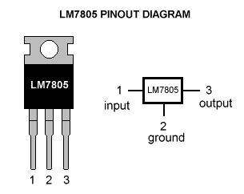

The **78xx** (sometimes **L78xx**, **LM78xx**, **MC78xx**...) is a family of self-contained fixed [linear voltage regulator](https://en.wikipedia.org/wiki/Linear_regulator) [integrated circuits](https://en.wikipedia.org/wiki/Integrated_circuits). The 78xx family is commonly used in electronic circuits requiring a regulated power supply due to their ease-of-use and low cost. For ICs within the family, the *xx* is replaced with two digits, indicating the output [voltage](https://en.wikipedia.org/wiki/Voltage) (for example, the 7805 has a 5-volt output, while the 7812 produces 12 volts). The 78xx line are positive voltage regulators: they produce a voltage that is positive relative to a common ground. There is a related line of **79xx** devices which are complementary negative voltage regulators. 78xx and 79xx ICs can be used in combination to provide positive and negative supply voltages in the same circuit.

78xx ICs have three terminals and are commonly found in the [TO-220](https://en.wikipedia.org/wiki/TO220) form factor, although they are available in surface-mount, [TO-92](https://en.wikipedia.org/wiki/TO-92), and[TO-3](https://en.wikipedia.org/wiki/TO3) packages. These devices support an input voltage anywhere from around 2.5 volts over the intended output voltage up to a maximum of 35 to 40 volts depending on the model, and typically provide 1 or 1.5 [amperes](https://en.wikipedia.org/wiki/Ampere) of [current](https://en.wikipedia.org/wiki/Electric_current) (though smaller or larger packages may have a lower or higher current rating).

**10k resistor**

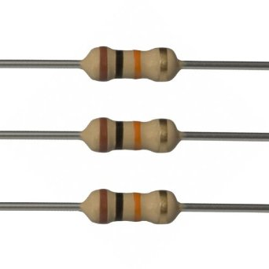

A **resistor** is a [passive](https://en.wikipedia.org/wiki/Passivity_(engineering)) [two-terminal](https://en.wikipedia.org/wiki/Terminal_(electronics)) [electrical component](https://en.wikipedia.org/wiki/Electronic_component) that implements [electrical resistance](https://en.wikipedia.org/wiki/Electrical_resistance) as a circuit element. In electronic circuits, resistors are used to reduce current flow, adjust signal levels, to divide voltages, [bias](https://en.wikipedia.org/wiki/Biasing) active elements, and terminate [transmission lines](https://en.wikipedia.org/wiki/Transmission_line), among other uses. High-power resistors that can dissipate many [watts](https://en.wikipedia.org/wiki/Watt) of electrical power as heat may be used as part of motor controls, in power distribution systems, or as test loads for [generators](https://en.wikipedia.org/wiki/Electric_generator). Fixed resistors have resistances that only change slightly with temperature, time or operating voltage. Variable resistors can be used to adjust circuit elements (such as a volume control or a lamp dimmer), or as sensing devices for heat, light, humidity, force, or chemical activity.

Resistors are common elements of [electrical networks](https://en.wikipedia.org/wiki/Electrical_network) and [electronic circuits](https://en.wikipedia.org/wiki/Electronic_circuit) and are ubiquitous in [electronic equipment](https://en.wikipedia.org/wiki/Electronics). Practical resistors as discrete components can be composed of various compounds and forms. Resistors are also implemented within [integrated circuits](https://en.wikipedia.org/wiki/Integrated_circuits).

The electrical function of a resistor is specified by its resistance: common commercial resistors are manufactured over a range of more than nine [orders of magnitude](https://en.wikipedia.org/wiki/Orders_of_magnitude). The nominal value of the resistance falls within the [manufacturing tolerance](https://en.wikipedia.org/wiki/Engineering_tolerance#Electrical_component_tolerance), indicated on the component.

# Results and Outcomes

## Results

# Conclusion and Future Work

## Conclusion

# References

|  |  |
| --- | --- |
| [1] | G. J. S. homas Wiegand, “Overview of the H.264/AVC Video Coding Standard,” in *IEEE transactions on circuits and systems for video technology, vol. 13*, 7, July 2003. |
| [2] |  |

Note: Use IEEE format

U can use Book, Magazine, Site etc.

# Annexure 1 Chart 1

Photo copy of chart/Canvas/Algorithm etc.

# Annexure 2 chart 2

# Annexure 3 chart 3

# Appendix